**ITM 311- Class Activity 4a (for Chapter 5) – Please highlight your answers!**

**Name: Erick Cabrera Date: 10/4/2016**

1) Which of the following expressions will determine whether x is less than or equal to y?

A) x <= y B) x >= y C) x > y D) x =< y

2) What will be the value of ans after the following code has been executed?

int x = 65;

int y = 55;

if (x >= y)

int ans = x + y;

A) 100 B) 10 C) 120 D) No value, there is a syntax error.

3) What will be the value of ans after the following code has been executed?

int x = 90, y = 55, ans = 10;

if ( x == y);

ans *= 2;

A) 145 B) 10 C) 20 D) No value, there is a syntax error.

4) A block of code is enclosed in a set of

A) braces B) double quotes C) brackets D) parentheses

5) If chr is a char variable, which of the following if statements is written correctly?

A) if (chr == 'a') B) if (chr = "a") C) if (chr = 'a') D) if (chr == "a")

6) What will be the value of pay after the following statements are executed?

int hours = 45;

double pay, payRate = 10.00;

pay = hours <= 40 ? hours * payRate :

40 * payRate + (hours - 40) * payRate * 1.5;

A) 465.00 B) 475.00 C) 450.00 D) 400.00

7) Which of the following is the correct boolean expression to test for: int x being a value between, but not including, 500 and 650, or int y not equal to 1000?

A) ((x > 500 AND x < 650) OR !(y.equal(1000))) B) ((x < 500 && x > 650) || !(y == 1000))

C) ((x >= 500 && x <= 650) && (y != 1000)) D) ((x > 500 && x < 650) || (y != 1000))

8) If str1 and str2 are both Strings, which of the following will correctly test to determine whether str1 is less than str2?

(1) (str1 < str2)

(2) (str1.equals(str2) < 0)

(3) (str1.compareTo(str2) < 0)

A) 1, 2, and 3 will all work. B) 2 C) 2 and 3 D) 3

9) What will be the values of ans, x, and y after the following statements are executed?

int ans = 35, x = 50, y =50;

if ( x >= y)

{

ans = x + 10;

x -=y;

}

else

{

ans = y + 10;

y += x;

}

A) ans = 60, x = 50, y =100 B) ans = 45, x = 50, y = 50

C) ans = 45, x = 50, y = 0 D) ans = 60, x = 0, y = 50

10) What will be the value of bonus after the following code is executed?

int bonus, sales = 10000;

if (sales < 5000)

bonus = 200;

else if (sales < 7500)

bonus = 500;

else if (sales < 10000)

bonus = 750;

else if (sales < 20000)

bonus = 1000;

else

bonus = 1250;

A) 500 B) 750 C) 1250 D) 200 E) 1000

**Programming Session**

**A health clinic would like a program that will enable their clients to enter their name, their body weight and their height. The program will return their BMI (body mass index), as well as their name, and submitted data. Usually the client will enter their weight in pounds and ounces and their height in feet and inches. If their BMI is greater than 30, they should be told they are obese. If their BMI is between 25 to 29.9, they should be told they are overweight. If their BMI lies between 18.5 and 24.9, they should be told they are normal. If their BMI is below 18.5, they should be told they are underweight.**

**To calculate Body Mass Index using the metric units, the body weight in Kilograms is divided by the square of the height in meters. Units would be kg/m2.**

**To calculate Body Mass Index using the English units, the body weight in pounds is divided by the square of the height in inches multiplied by 703.**

**See:** [**https://www.freebmicalculator.net/calculate-bmi.php**](https://www.freebmicalculator.net/calculate-bmi.php)

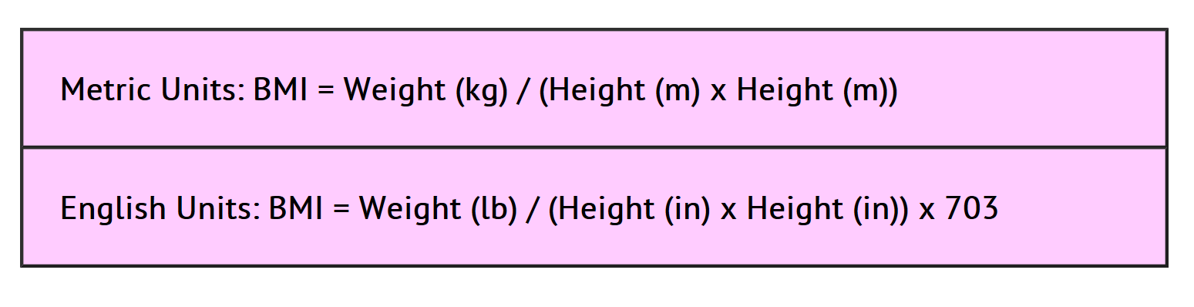

**To convert from pounds to kilograms, use the conversion factor of 1kg = 2.2lb.**

**To convert from feet to meters, use the conversion factor of 1 m = 3.2808 feet.**

**To convert an ounce to a pound, use the conversion factor of 1 lb = 16 oz.**

**To convert an inch to a foot, use the conversion factor of 1 foot = 12 in.**

**import java.text.DecimalFormat;**

**import java.util.Scanner;**

**public class BMI {**

**public static void main(String args[]){**

**Scanner sc = new Scanner(System.in);**

**System.out.print("Please enter your name: ");**

**String name = sc.nextLine();**

**System.out.print("Please enter your weight in pounds and ounces (Ex: 190.5): ");**

**double weight = sc.nextDouble();**

**System.out.print("Please enter your height in inches: ");**

**double height = sc.nextDouble();**

**double bmi = weight / (height * height) * 703;**

**DecimalFormat form = new DecimalFormat("0.0");**

**String status;**

**if(bmi > 30.0){**

**status = "you are obese.";**

**} else if(bmi >= 25.0 && bmi <= 29.9){**

**status = "you are overweight.";**

**} else if(bmi >= 18.5 && bmi <= 24.9){**

**status = "you are normal.";**

**} else{**

**status = "you are underweight.";**

**}**

**System.out.println("Hello " + name + "! \n" +**

**"Based off of your weight (" + weight +**

**" lbs) and height (" + height + " in), \n" +**

**"I calculated that your BMI is +" +**

**form.format(bmi) + "\nMeaning " + status);**

**sc.close();**

**}**

**}**

